TENTH ANNUAL WALT WHITMAN HIGH SCHOOL POMS CLINIC 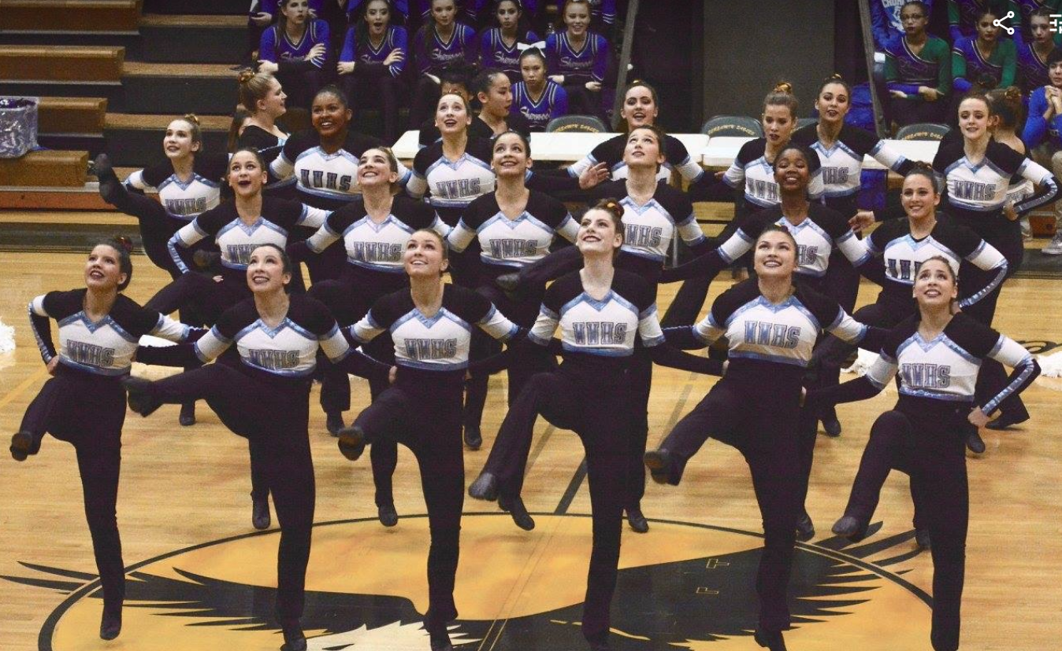
Saturday, November 6th, 2021
9:00 am—12:00 pm
(Parents should return at 11:20 a.m. for clinic demonstration)
Walt Whitman High School Gym
7100 Whittier Boulevard, Bethesda, MD

Join the 2021-22 Walt Whitman Varsity Poms for a fun morning of dance!
Participants will be placed in age appropriate groups to learn a dance routine from the Walt Whitman Poms Squad.
Who: Kids Grades K-8 and the Walt Whitman H.S. Varsity Poms Squad
What to wear: Shorts, sneakers, t-shirt
What to bring: Water and snack (peanut-free, please!)
Cost: $40 per student, includes clinic, t-shirt and mini pompons to take home
Child 1: First & Last Name:
Age: Grade:
School:
Shirt Size (Please circle): Child Small Child Medium Child Large Adult Small
Child 2: First & Last Name:
Age: Grade:
School:
Shirt Size (Please circle): Child Small Child Medium Child Large Adult Small
Parent/Guardian’s First & Last Name:
E-mail Address:
Cellphone:
Emergency Contact Name & Phone (if different from parent’s contact info above):
Pay by Venmo @Hillary-Mintz
Online payment at https://www.pay4schoolstuff.com

Total Amount Enclosed:
WAIVER STATEMENT I approve of my child’s attendance at this Walt Whitman HS Poms activity and certify that he/she is in good health and is fit to participate. I understand that there are inherent risks in this activity, which have been considered and which the participant assumes. Participant has medical insurance. I agree to hold harmless Walt Whitman HS, Walt Whitman HS Poms, and their agents from claims of damages due to injury to person or property caused by act or failure to act of the Walt Whitman HS Poms.
SIGNATURE: DATE: :
Questions? Please e-mail sanderskd@verizon.net. Walk-ins welcome, but no guarantee of t-shirt/mini pompoms unless registration received by 10/31/21.

